CS 255 System Design Document Template

This template lays out all the different sections that you need to complete for Project Two. Each section has guidance to prompt your thinking. You will need to continually reference the interview transcript as you work to make sure that you are addressing your client’s needs. There is no required length for the final document. Instead the goal is to complete each section based on what your client’s needs are. Remove this note when you are finished, and replace all bracketed text with the relevant information.

UML Diagrams

UML Use Case Diagram
[In Module Six, you were asked to complete a use case diagram based on your system design. If you would like to make any adjustments to your diagram, please do so. Please insert your use case diagram here. Check to make sure that you included appropriate components and symbols and that your design meets the client’s needs.]
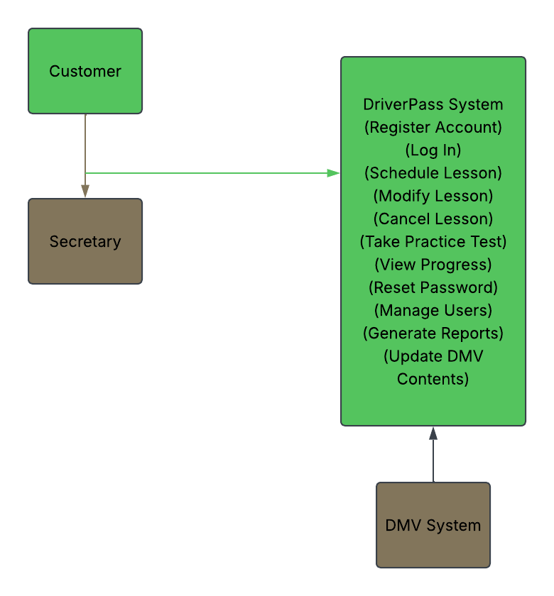

UML Activity Diagrams
[You were asked to choose two use cases and create two activity diagrams, one for each use case. Please insert both of your activity diagrams here. Check to make sure that you included appropriate components and symbols and that your design meets the client’s needs.]

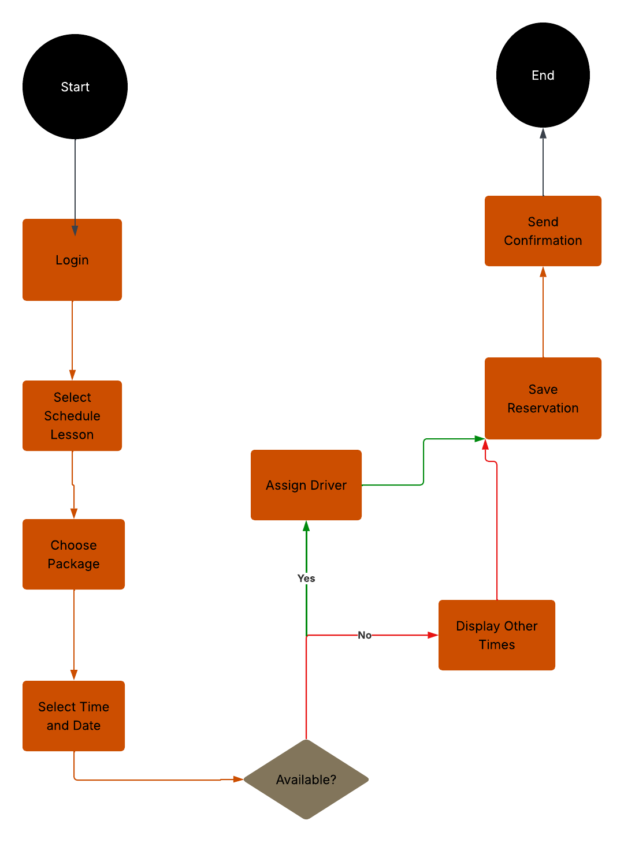

UML Sequence Diagram
[You were asked to create a sequence diagram based on one of the use cases you chose. Please insert your sequence diagram here. Check to make sure that you included appropriate components and symbols and that your design meets the client’s needs.]
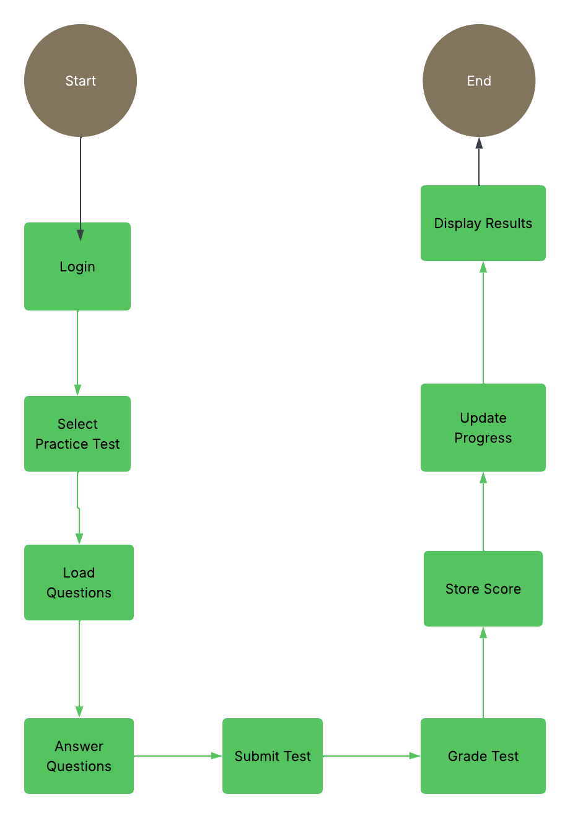

UML Class Diagram
[You were asked to create a class diagram based on the different classes and attributes needed for your system design. You are not required to include methods, but you may if you wish. Please insert your class diagram here. Check to make sure that you included appropriate components and symbols and that your design meets the client’s requirements.]

Technical Requirements
The DriverPass system will be a cloud-based web application that allows customers and employees to access the system through desktop computers, laptops, tablets, and mobile devices. The system will require internet access to update records and synchronize information across all users.
Hardware Requirements
- Cloud-hosted servers to store application and customer data
- Desktop computers for office staff
- Mobile devices, tablets, and computers for customers
- Printers for reports and business documents
Software Requirements
- Modern web browsers such as Google Chrome, Microsoft Edge, Firefox, or Safari
- Database management system for storing customer, reservation, and testing information
- Microsoft Excel support for exporting reports
- Operating systems capable of running modern web browsers
Infrastructure Requirements
- Cloud hosting services
- Secure database storage
- Reliable internet connectivity
- Automated backup and recovery services
- Security Requirements
- Username and password authentication
- Password reset functionality
- Role-based access control for customers, secretaries, administrators, and management
- Activity logs to track user actions
- Secure storage of customer and payment information
The system will also connect with DMV information updates so that practice tests and training materials remain current. The cloud-based design provides flexibility, accessibility, and data protection while supporting DriverPass business operations.

